**Biology: 7. Respiration**

***Please remember to photocopy 4 pages onto one sheet by going A3→A4 and using back to back on the photocopier***

**Syllabus**

**OB9** Describe the process of aerobic respiration by means of a word equation and understand that aerobic respiration requires the presence of oxygen

**OB10** Demonstrate the products of aerobic respiration

**OB11** Carry out qualitative tests to compare the carbon dioxide levels of inhaled and exhaled air

**OB12** Describe how oxygen is taken into the bloodstream from the lungs and how carbon dioxide is taken into the lungs from the bloodstream during gaseous exchange and how these processes are affected by smoking

**Student Notes**

**Respiration**

**Respiration is the controlled release of energy from food**

***Respiration is not the same as breathing!!***

Respiration can be either aerobic or anaerobic.

Aerobic respiration requires oxygen while anaerobic does not.

Humans and all other animals carry out aerobic respiration while many micro-organisms like yeast carry out anaerobic respiration

**Equation for aerobic respiration**

**Glucose + oxygen → Energy + carbon dioxide + water**

**Test for CO2**

It turns limewater milky.

**Test for water**

It turns anhydrous copper sulphate from white to blue.

**To show that there is more carbon dioxide in exhaled air than in inhaled air.**



1. Suck air in through the position shown on diagram A and note that the limewater takes a long time before going milky.
2. Replace the limewater and this time exhale air through the top of the tube as shown in diagram B and note that the limewater goes milky quickly.
3. Conclusion: there is more carbon dioxide in exhaled air.

**Breathing happens when animals take in oxygen and give out carbon dioxide and water**

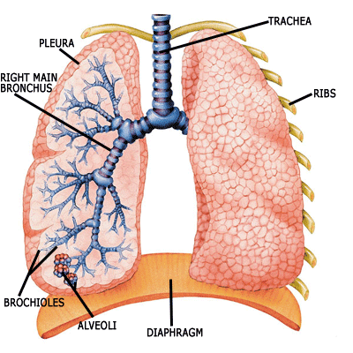

**How does air enter and leave the lungs?**

1. The diaphragm contracts (this is you ‘sucking up’), pulling the ribcage down.
2. The ribcage is attached to the lungs and as a result air is taken in when the mouth (or nasal passage) is open.
3. In order to exhale, the diaphragm relaxes, pushing the ribcage up so if the mouth is open air will escape.

**Gaseous exchange:**

**How oxygen is taken *into the bloodstream* and carbon dioxide and water *leave the bloodstream***

Air passes in and out of the lungs via the trachea (windpipe),

The diagram shows tiny air sacs called alveoli.

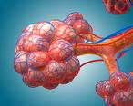Each alveolus is surrounded by tiny blood vessels called capillaries.

Gaseous exchange takes place here.

Oxygen passes from the alveoli into the blood which is flowing through the capillaries,

Carbon dioxide and water pass in the opposite direction; from the bloodstream back into the alveoli where they are exhaled back out of the body.

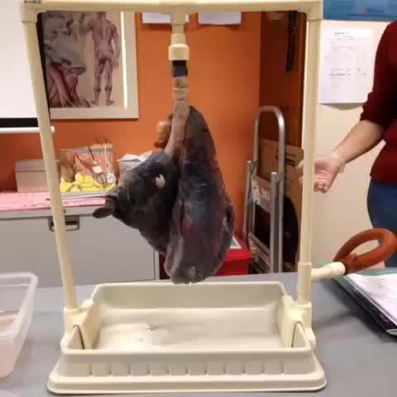

**The effect of smoking**

Smoking has many adverse health effects, including:

* Cancer
* Heart disease
* Pneumonia
* Bronchitis
* It clogs up the hairs in the nose, which reduces their effectiveness to filter incoming dust particles.
* It also clogs up the alveoli in the lungs, reducing the ability to exchange gases.

**Exam Questions**

1. [2008 OL][2007][2012 OL]

Complete the following word equation for aerobic respiration.

Glucose (Food) + ____________ → Energy + _______________ + Water

1. [2007]

State how you would show the presence of the products of aerobic respiration by means of a chemical test.

1. [2007 OL]

Limewater was placed in test tube A and in test tube B.

* 1. What effect has carbon dioxide on limewater?

The student inhaled through test tube A and exhaled through test tube B twenty times.

The student saw no change in the appearance of the limewater in test tube A. The appearance of the limewater in test tube B had changed.

* 1. What change would you expect the student to have seen in the limewater in test tube B?
  2. What conclusion should the student have drawn from what he/she saw?

1. [2006]

The diagram is of an apparatus used to show that exhaled air contains carbon dioxide.

When performing this experiment a control is required to show that inhaled air contains less carbon dioxide than exhaled air.

Describe, using a labelled diagram, a suitable control procedure.

1. [2009]

The diagram shows the apparatus used by a pupil when performing an experiment in a school laboratory.

The pupil blew (exhaled) air into test tube X.

The pupil sucked (inhaled) air from test tube Y.

The pupil continued, alternately, blowing and sucking air, as above, until liquid A in one of the test tubes turned milky.

1. Name liquid A.
2. In which test tube, X or Y, did the liquid turn milky?
3. Why did liquid A turn milky in one of the test tubes?
4. What conclusion can be made from the result of this experiment regarding the difference in composition between exhaled and inhaled air?
5. Complete the word equation, below, for aerobic respiration.

Food + ___________ → _____________________ + energy + water

1. [2010] [2006]

The diagram shows the internal structure of a human lung. There are about 350 million alveoli per lung.

Describe clearly the exchange of gases that occur between the air in the alveoli and the bloodstream.

1. [2006 OL]

The heart pumps blood to the lungs and around the body.

The diagram shows part of the breathing system.

* 1. Name the parts of the breathing system labelled X and Y in the diagram.
  2. Complete the sentence below..

There is more ____________________ in exhaled air than in inhaled air.

* 1. A balance of exercise and rest promotes good health.

****Name one activity which has a harmful effect on the breathing system.

1. [2010 OL]

The diagram shows part of the human breathing system.

1. Name the parts labelled A and B in the diagram.
2. Part A has rings of cartilage.

What do the rings of cartilage do?

1. In which part of the breathing system does the gas exchange take place?
2. Why does exhaled air turn limewater milky?



1. [2009 OL]

The diagram shows a model of the human breathing system.

1. Name the part of the breathing system represented by the balloons.
2. Choose from the list on the right the correct word to complete the sentence below.

The part of the breathing system represented by the bell-jar is the ___________.

**Exam Solutions**

1. Missing reactant: oxygen (O2)

Missing product: carbon dioxide (CO2)

1. Test for CO2: it turns limewater milky.

Test for water: it turns cobalt chloride paper pink / it turns copper sulphate blue.

1. 
2. It makes carbon dioxide turn milky.
3. It turned milky.
4. There is more carbon dioxide in exhaled air than in inhaled air.
5. Air entering tube as shown

Gas being removed as shown

1. Limewater
2. X
3. Because it contained carbon dioxide
4. There is more carbon dioxide in exhaled air
5. Food + oxygen → carbon dioxide + energy + water
6. Oxygen passes out of the alveoli and into the bloodstream.

Carbon dioxide passes out of bloodstream and into the alveoli.

1. X: Trachea / windpipe B: Alveolus / alveoli / airsac(s)
2. Carbon dioxide
3. Smoking
4. A: Windpipe / trachea

B: Lung

1. Keep air tubes open / stops collapse [accept “supports”]
2. Alveolus / alveoli / air sac(s)
3. Exhaled air contains carbon dioxide
4. The lungs
5. The rib cage

**Other Test Questions**

1. Define the term *respiration*.
2. Give the word equation for respiration.
3. When a student exhales into a test-tube surrounded by a freezing mixture of ice and salt a colourless liquid is formed.
4. What is this liquid and describe a test to prove it.
5. Why is necessary to put the test-tube in a freezing mixture?
6. What is *anaerobic* respiration?
7. Draw a labelled diagram of the lungs – include trachea, bronchi, bronchioles and alveoli.
8. Give two effects of smoking on the breathing system.